Muhammad Owais

Question 1

-------------------------------------

Question Number 2

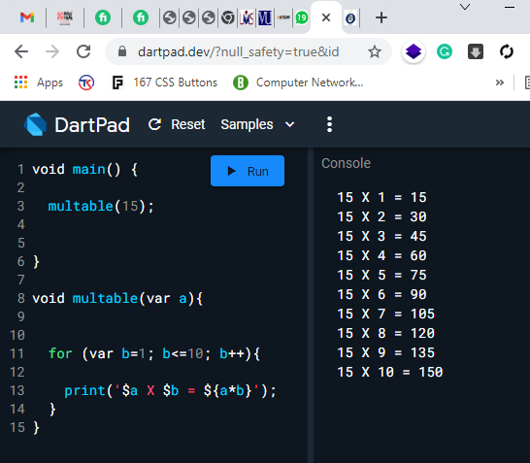

Question number 3

List lst = [2,4,6,8,9];

Make a function that takes a number as parameter and divide that parameter to every element

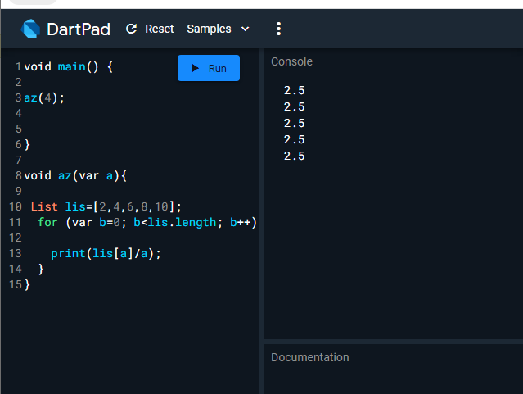

Question Number 5

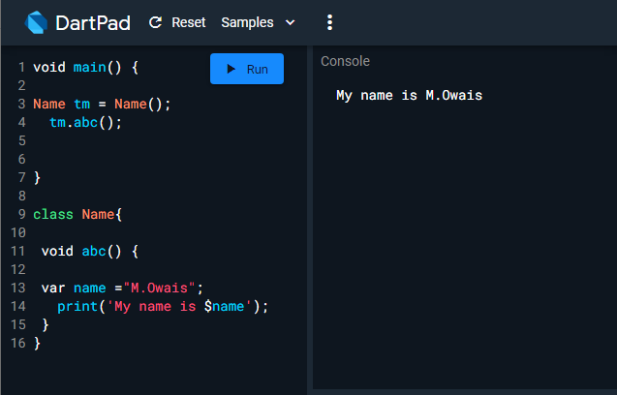

Question number 6

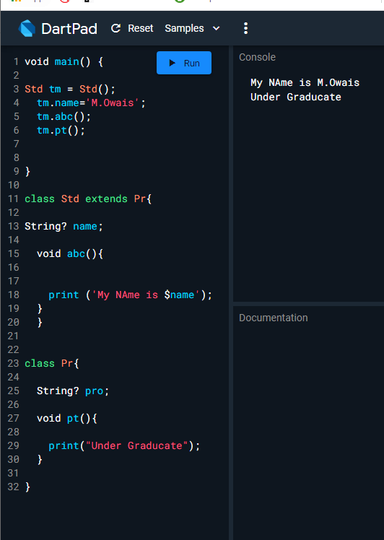

Question 8

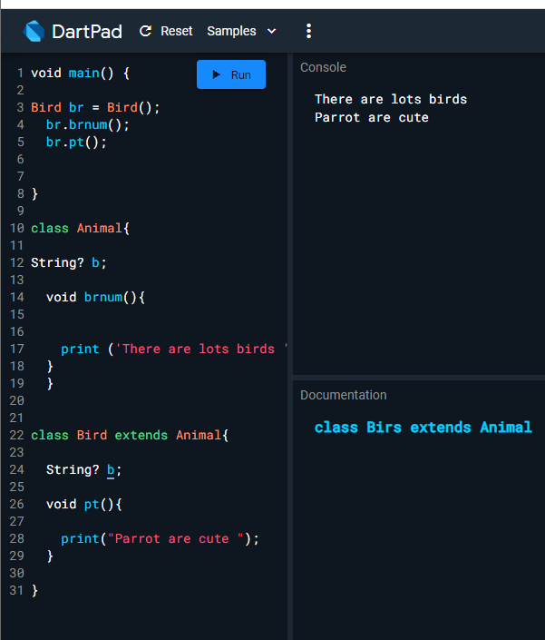

Sorry For late submission Cause of Computer Issue